**Architecture Document**

**for the**

**SIUE Department of Computer Science**

**CS425 / CS499 Senior Project**

**Software Design and Implementation Courses**

**by**

**Zach Benchley, Matt Lievens, Logan Maughan, Brian Olsen**

**of**



**Learning Outcomes-Based Assessment Database Team**

Revision 1.0

As Of: September 28, 2013

LOBA-PP-ARCHITECTURE

Change Log:

|  |  |
| --- | --- |
| Revision | Change Note(s) |
|  |  |
| 1.0 | * Initial Release |

Reviewed and Approved By:

Name Signature Date

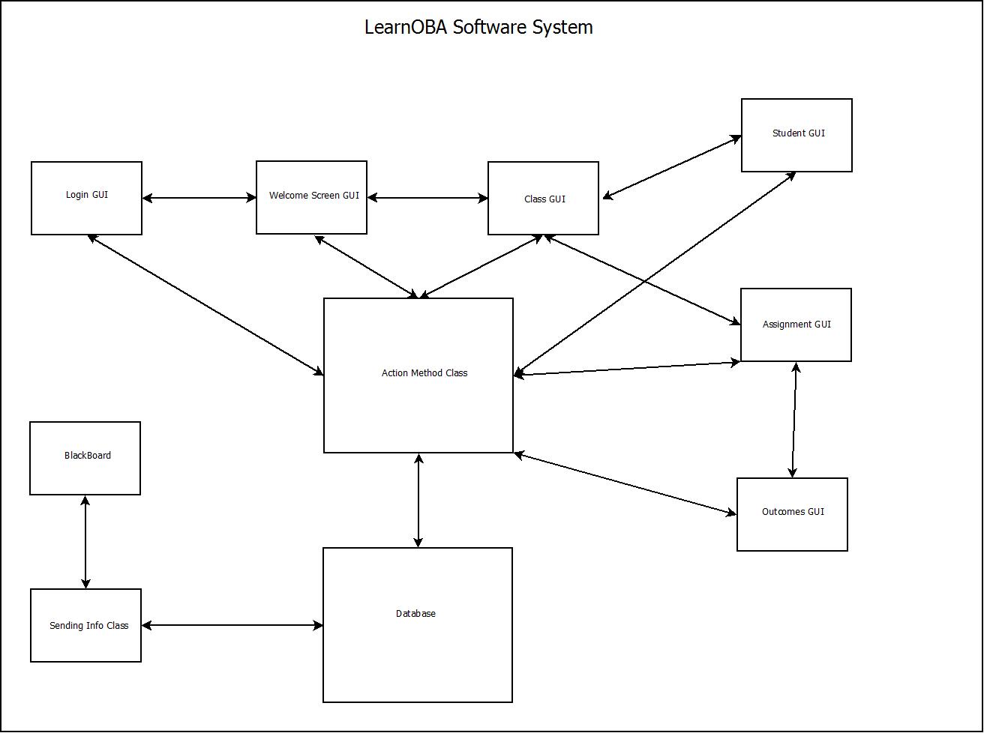

Note: Blackboard is a system that has already been developed. The team is just facilitating information to and from Blackboard without modifying any of its components.

Figure 1 - LearnOBA Software System Flow Diagram

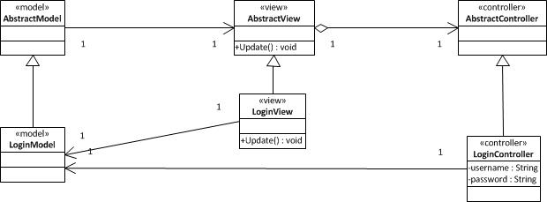

Figure 2 - MVC Model for Login



Figure 3 - Database Model

Figure 3 shows a very basic design for the database. It shows some of the basic fields that the main database tables will have to have, as well as the basic way the tables will relate to one another.